

***Gifted Parent Quarterly***

***Coordinator’s Corner***

**Welcome, families, to our Dallas gifted and talented community! It’s hard to believe that the first half of the 2015-16 school year is almost over. From new projects, to guest speakers, to field trips, the fall semester has been an exciting time full of learning. Thanks for all of our support at home and on campus, and we look forward to watching your students *grow and know into 2016!***

**-Kari Lockhart**

**Dallas-Area Gifted & Talented Program Coordinator**

*What’s Happening on Campus?*

Students at Harmony-Dallas Elementary hosted Santiago Gutierrez, who spoke to the third grade GT students about starting his own business and creating an interactive dog toy called "GoBone". He took the toy apart to show them exactly what went inside and went over the process of how his GoBone went from just an idea to the prototype he brought in. (below)

Harmony-Dallas Middle School students participated in a demo with TI's Launchpad. The students were able to write code and program their own circuit boards. This activity was so much fun, TI donated a free Launchpad to the school! (left)

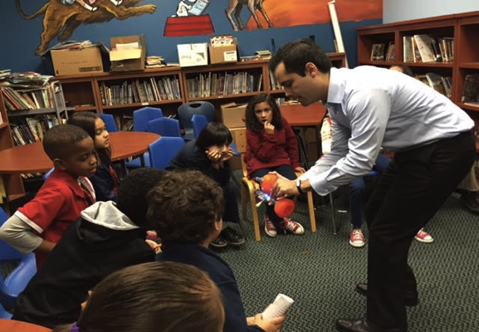 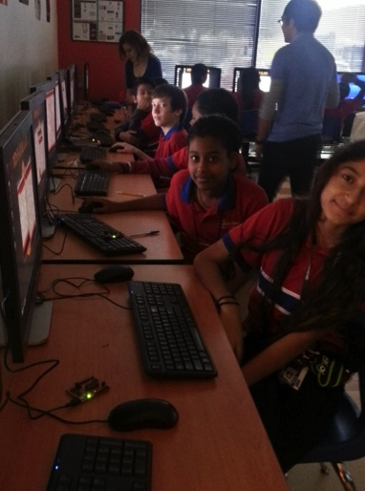

***WELCOME, new Campus Coaches!***

*Do you know?*

HPS Dallas GT has a web site! Check us out at harmonydallasgate.weebly.com. This site outlines upcoming community events, and contains parent resources, home connections, campus documents, and more!

* Mr. Michael Hanson, *Harmony School of Business*
* Ms. Crystal Martin, *Harmony School of Innovation*
* Mr. David Odle, *Harmony School of Innovation, Garland*

HAS Garland Elementary students hard at work on their Passport Night projects. Students also learned about oceanography on their field trip to the Seal Life Aquarium. (below)

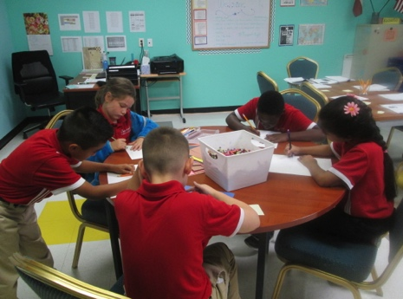 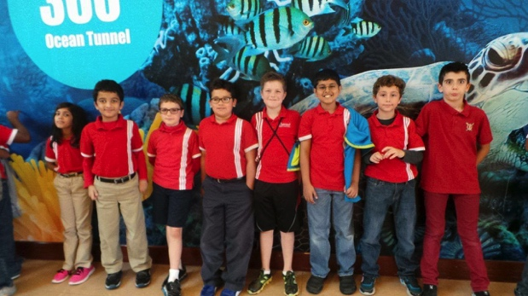 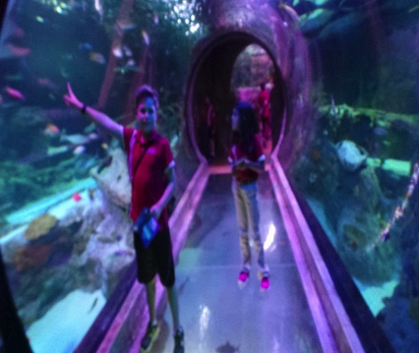

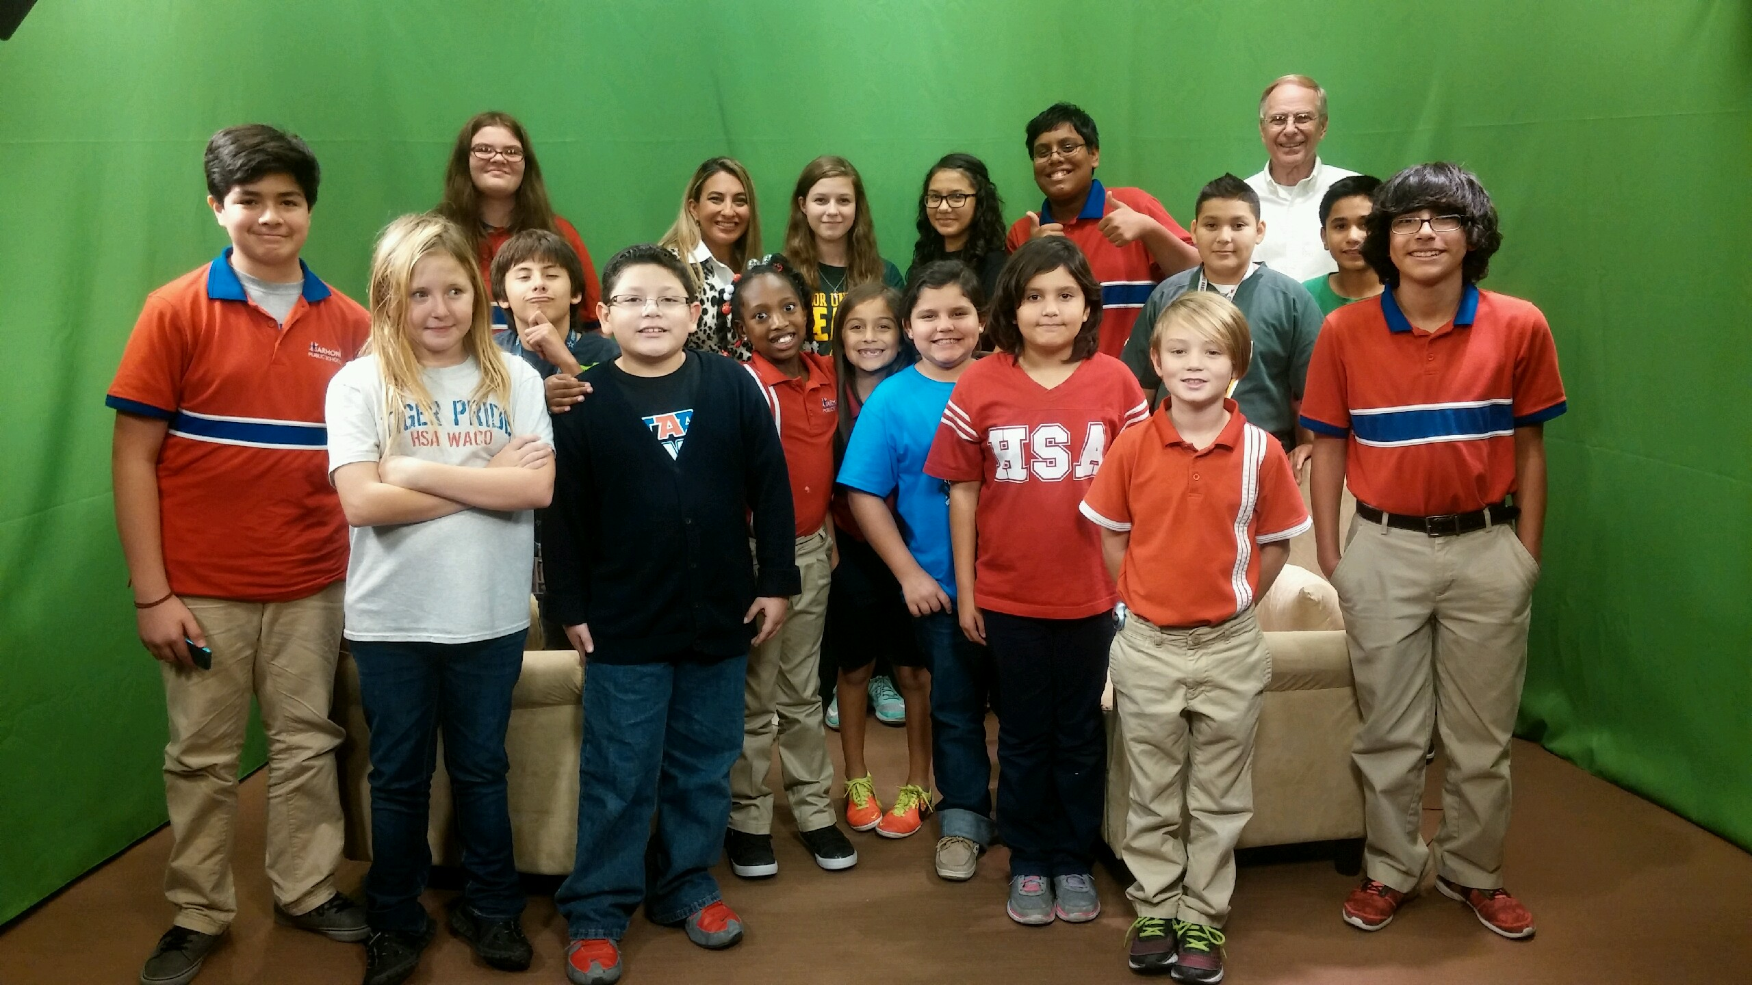

Students at HSA Waco took a field trip to their local news studio to learn about the production process and media in their community. As an added surprise bonus, they got to watch their assistant principal being interviewed! (right)

Parent Resources

Get involved!

Consider joining the Texas Association for the Gifted & Talented as a parent member. Members recieve access to resources, opportunities to network within the gifted community, and the latest information on gifted programming in Texas.

Target First Saturdays at the Nasher Sculpture Center

Families get free entry to the Nasher Sculpture Center, as well as access to different activities and unique learning opportunities. (More info: nashersculpturecenter.org)

*The Maker Mom*’s blog (themakermom.com) focuses on raising students in a STEM-rich (science, technology, engineering, and mathematics) environment that focuses on innovation and creativity.



